1. 
2. When we say installing elasticsearch on windows, this is not entirely true as we will be not installing elasticsearch as application. This is because elasticsearch consists of some jar files (**Jar**: File that aggregates java class files).  
   Elasticsearch is also packaged as jar file with its dependencies such as **Lucene**.

Running elasticsearch is as easy as running a script file that is distributed with the jar file.

1. The point is we will not be installing anything but rather downloading files needed to run elasticsearch.
2. **OpenJDK**: Elasticsearch ships with a version of openJDK which means you don’t need to install JDK.
   1. If you have set environment variable **JAVA_HOME**, elasticsearch would use that JDK otherwise it uses the openJDK bundled with it.
3. **Download Link**:  
   <https://www.elastic.co/downloads/elasticsearch>
4. 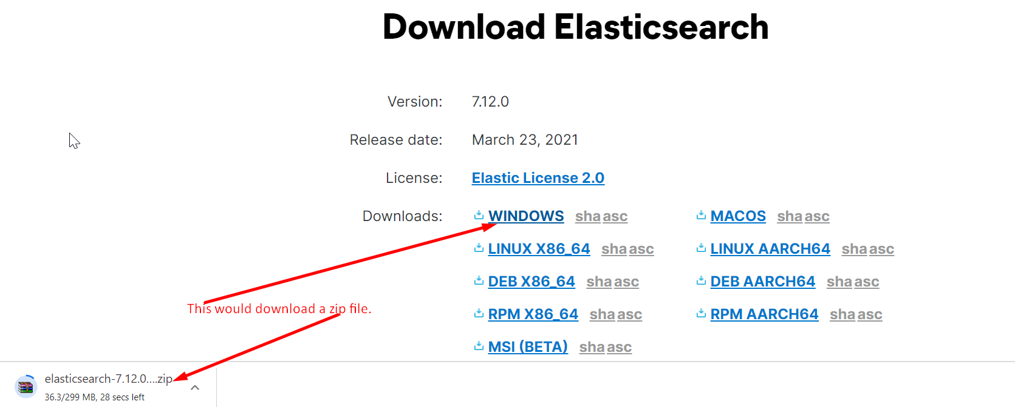
5. 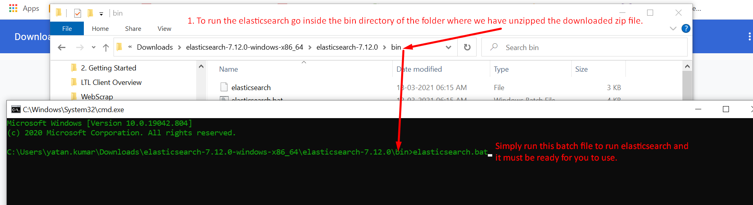
6. When we run the above batch file, the following happens.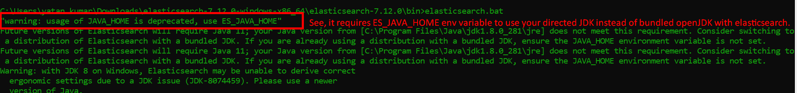
7. 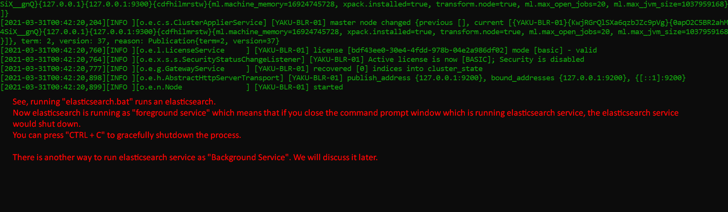
8. To be 100% sure about whether the elasticsearch service is running properly, we will send HTTP request to elasticsearch which is running locally on 9200 port no.
9. Elasticsearch exposes its services as RESTfull endpoints.
10. To send HTTP request, we will use **command line tool CURL** but we can use any HTTP client such as POST.
11. 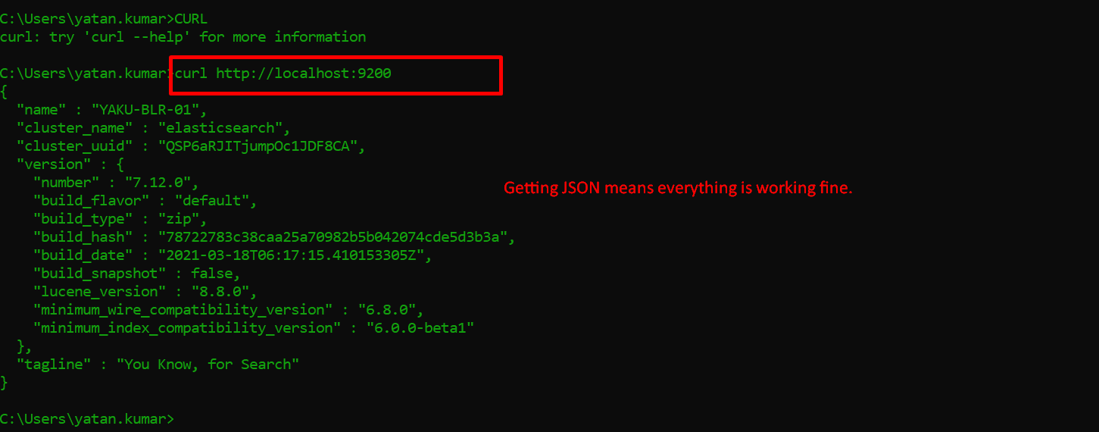  
    **NOTE**: by default HTTP GET method would be called in the above CURL command.
12. 